Project report template

Introduction:

Resume design which is the look, structure and format of your resume is very important to enhance the content of the resume.

Problem definition & design thinking:

2.1.Empathy map:

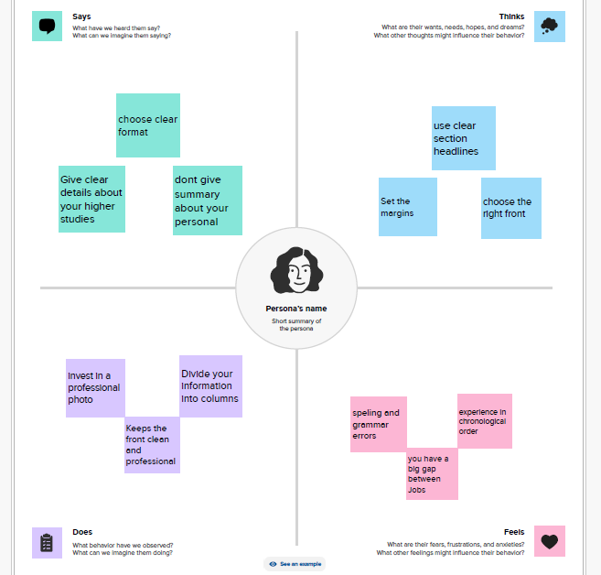

2.2.Ideation & Brainstorming map:

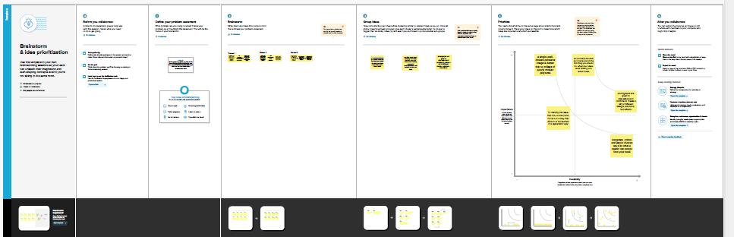

Result:

Final finding (output) of the project along with screenshots.

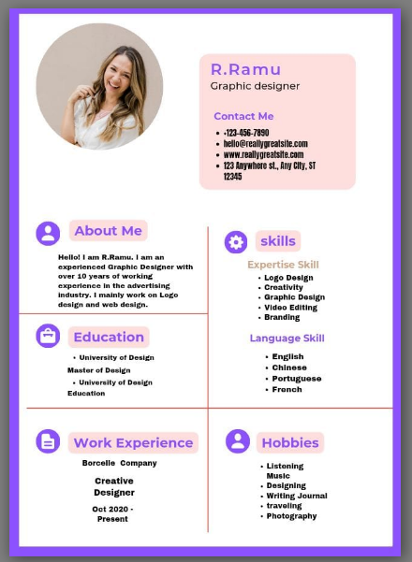

Advantages:

Skills/experience from not so recent jobs can be emphasized. Objectives may be different from your experience.

Disadvantages:

Employers may resume all skills are current, absence of dates may confuse employers.

Application:

I used phone through canva website

Conclusion:

I learn how to use the canva with edit the design